Japanese Parser Project Part A

RE = (vowel | vowel n | consonant vowel | consonant vowel n |

consonant-pair vowel | consonant-pair vowel n)^+

Vowels are **a e i o u**  where **i** and **e** can be uppercase

NFA-e

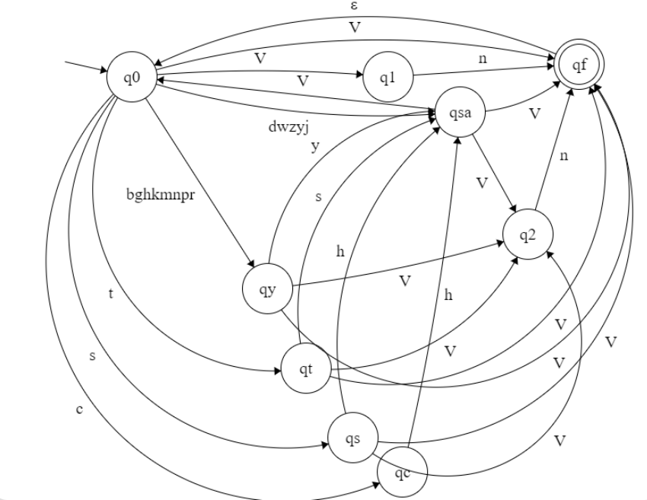

NFA

q0 and qf merged

q1 and q2 merged

V = vowels, are - a, e, i, o, u, I, E

Next step it to transform this to a DFA

